¿Qué es Data Mining?

El data mining es un conjunto de técnicas y tecnologías que permiten explorar grandes bases de datos, de manera automática o semiautomática, con ayuda de la tecnología. Con el objetivo de encontrar patrones repetitivos, reglas o tendencias que sirvan como información valiosa en distintas áreas de una empresa.
Un trabajo de minería de datos consta de las siguientes partes:
- Entendimiento del problema: se trata de hablar con el cliente, conocer sus necesidades, conocer su negocio o actividad, conocer qué datos relevantes tiene disponibles y cuáles serían necesarios pero no están disponibles, etc.
- Entendimiento de los datos: hay que saber qué significan esos datos, si son continuos o discretos, qué tipo de valores toman, qué utilidad futura pueden tener y saber si están bien capturados o no.
- Preparación de datos: se trata de reflexionar sobre cómo guardar los datos. Típicamente hablaremos de tablas con filas y columnas, pero hay que ver cómo se organizan las tablas, cómo se interrelacionan entre ellas, etc. En definitiva organizar los datospara poder sacarles partido.
- Modelamiento: una vez que se tienen los datos organizados hay que definir los algoritmos que se van a utilizar para tratar los datos. Una vez tratados, los datos nos devolverán información útil.
- Evaluación: los resultados obtenidos deben de ser sometidos a comprobación, verificar que están libres de errores, ratificar que son útiles para los objetivos perseguidos, etc.

Data Acquisition System

A data acquisition system (DAQ) is an information system that collects, stores and distributes information. It is used in industrial and commercial electronics, and environmental and scientific equipment to capture electrical signals or environmental conditions on a computer device.A data acquisition system is also known as a data logger.

Sistema en el cual se conecta, guarda y distribuye la información.

Data acquisition is the process of digitizing data from the world around us so it can be displayed, analyzed, and stored in a computer. To help you choose the right tool for your application, we have a complete guide to DAQ systems in 2018 on our website. Let’s go over the basic components of a DAQ system, and if you want more information about the various options for your application, check out the full post at mccdaq.com/data-acquisition.

La adquisición de datos es el proceso de digitalización de información del mundo que nos rodea para que se pueda visualizar, analizar y almacenar en una computadora.

Sistema en el cual se conecta, guarda y distribuye la información que nos rodea para que se pueda visualizar, analizar y almacenar en una computadora.

Data Driven Modelling

Lately, the oil and gas industry has had the need for new technologies and processes to seize and transform data into strategic business intelligence for enhancing exploration and production, improving refining and manufacturing efficiency and optimizing global operations while ensuring safety and environmental protection. With the advent of machine learning, data mining, optimization and cloud computing, it is now possible to manage large amounts of data as never before (Dursun et al, 2014). The objective of data driven methods is to provide the strategy required to utilize data collection and selection to optimize business outcomes and decision making while helping to minimize risk. The development of data driven methods involves combining a variety of cutting-edge machine learning and data-mining techniques as well as data management strategies to provide fit–for-purpose descriptive, research, predictive, and prescriptive models. Hence, the development team should have a deep understading of both underlying data science and the business model, as well as software engineering principles.

Data Mining & Data Acquisition

Technology advancement in computing power in the last few decades has allowed for a paradigm shift from theoretical to computational problem solving. As a result, historical data is being used more efficiently to develop, verify and validate physical theories. Computational paradigm, as with the case of previous techniques, involves modeling and simulation of complex proccesses using available data to minimize the standard deviation error between estimated output results and measured data relevant to these processes (Maysami et al, 2013) Data mining becomes valuable when the conventional reservoir monitoring methods fail to decide field development strategy due to high amounts of uncertainties. Data mining can be defined as extracting hidden patterns from data, especially for cases with more available data. Preparing data becomes time consuming, and more importantly, when there is the need to deal with abnormal patterns of data (Obulesu et al, 2014; Termizel et al, 2016) In the oil and gas industry, data acquisition is extremely costly due to presence of uncertainties. Brown fields pose a challenge due to the lack of any type of data other than production rates. Thus, it can be said, with a good degree of confidence, that a limiting factor in most conventional reservoir simulation techniques is the presence of insufficient data.

Data Driven Techniques

Reservoir engineering has been integrated with Artificial Intelligence and Data Mining (AI&DM) as the data driven technique in our analysis. Discussed below are a list of processes that were implemented in the study of,

1. Hilighted field dataset review and preparation

◦ Well Logs (available) and Reservoir Characteristics (petrophysical properties)

◦ Production history

◦ Completion details ◦ Workovers and stimulation treatments

2. Delineation and Volumetric Calculations (on a per-well basis)

3. Fuzzy Pattern Analysis

◦ Well Quality Analysis

◦ Fuzzy Trend Analysis

◦ Key Performance Indicators Analysis (KPI)

4. Field-Wide Fuzzy Pattern Recognition

◦ Fixed interval well performance

◦ Remaining reserves estimation (time dependent)

◦ Recovery factor estimation

5. Top-Down Model Development:

◦ Production forecast of proposed wells

◦ Economic analysis

On the other hand, there are multiple methodologies involved in the generation of these data driven models, which mainly include – data gathering, data selection, identification of key attributes, history matching and forecasting. Data gathering can vary form simple frequent gathering of data, to storage of data, reporting, documentation and integration. It includes the use of smart wells, such as ICVs, and regular rate recording. Acquisition of data inludes data such as well trajectories, well interventions, production/injection data, coordinated maps, well logs & petrophysical models and geological reservoir models. Storage of this data includes various methods – SQL server integration, volume analysis, Integrated Asset Management (IAM), pumping & drilling databases (Termizel et al, 2016). Machine Learning is the field of study that gives computers the ability to learn without being explicitly programmed. It has been widely employed in a range of computing tasks when it's not feasible to define the rules by hand. There are some techniques of Machine Learning methods based on data driven models, such as Artificial Neural Network (ANN), Capasistance Resistance Models (CRM). Another data driven method is Intelligent Production Data Analaysis (IPDA), that combines conventional production data analyisis methods with new generation intelligent methods (Neural Network, Genetic Algorithms and Fuzzy Logic). Prior to lease acquisitions, for independent asset valuation requirements, IPDA is providng to be a valuable tool. The technique has been applied in several fields around the United States. (Mata et al, 2007). Several data-driven models have been used to optimize field operations and waterflooding projects. Datadriven methodologies used in the oil industry includes – artificial intelligence like neural networks and fuzzy logic and the ones based on driven-model solutions like capacitance-resistance models. In all these methodologies, special care must be considered during data acquisition of variables such as well trajectories, well intervention, production/injection data, coordinated maps, well logs and petrophysical properties and geological information. Data processing and cleaning should be carried out in to get the most accurate results (Temizel et al., 2017). The application of each data-driven model has its own advantages and drawbabacks, these features will be summarized in the following section.

Artificial Neural Networks (ANN)

It is one of the most popular machine learning methods in the oil industry. ANN is a data-driven methodology, which means that it is completely based on data and not on governing physics. The solution obtained by this method is "learned" or driven from data without assuming a predetermined equation as a model. ANN has been increasingly used in many fields. The ability of managing big amounts data and their non-linear relationships to give multiple responses in complex systems is one of the main features of ANN methods. ANNs form a broad range of algorithms that can solve several types of problems, including pattern classification, function approximation, pattern completion, filtering, optimization and automatic control (Jia and Zhang, 2016). ANN methods should undergo a training process. The trained and verified model can then be used for prediction based on the input parameters. Jia and Zhang (2016) reported that ANN models can provide much more accurate predictions than classical empirical models. A way to improve the ANN model accuracy and performace is reducing noise in the input data, by including only filtered and verified information. The authors of this work report that the proposed methods can account for important physical parameters of prediction and forecasting. Jia and Zhang (2016) showed few applications of this techonology in different projects around the world. One of the main advantages of ANN is that it may help in decreasing the amount of iterations to obtain

history match in reservoir models (Mohaghegh (2000), Ramgulam et al. (2007)); a feed-forward ANN was used to train more than 90 days of production period. The parameters used in their model include production pressure, permeability, porosity and thickness. Their work gave some insight into the development of ANN for history matching and the prediction of variables to get a better understanding of the reservoir. ANN has been also used as a probabilistic tool based on user knowledge and historical data to estimate the potential of water production (Hermann et al., 2012).

Benefits of Data-driven Approach where historical data is utilized efficiently

• Well-organized historical field database for field development

• Benchmarking scope-for-recovery and reserves estimation

• Best practice sharing

• Decision making under limited information or high uncertainty

• Preferred development options and recovery factors

• Understanding of uncertainties for field and reservoir appraisal

• Assistance in technical and economic scenario modeling

• Better decisions for future operations

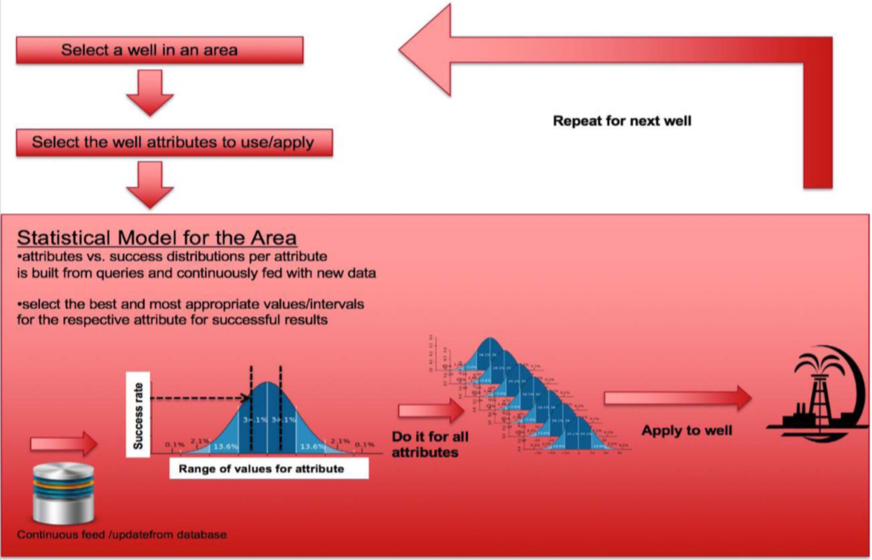

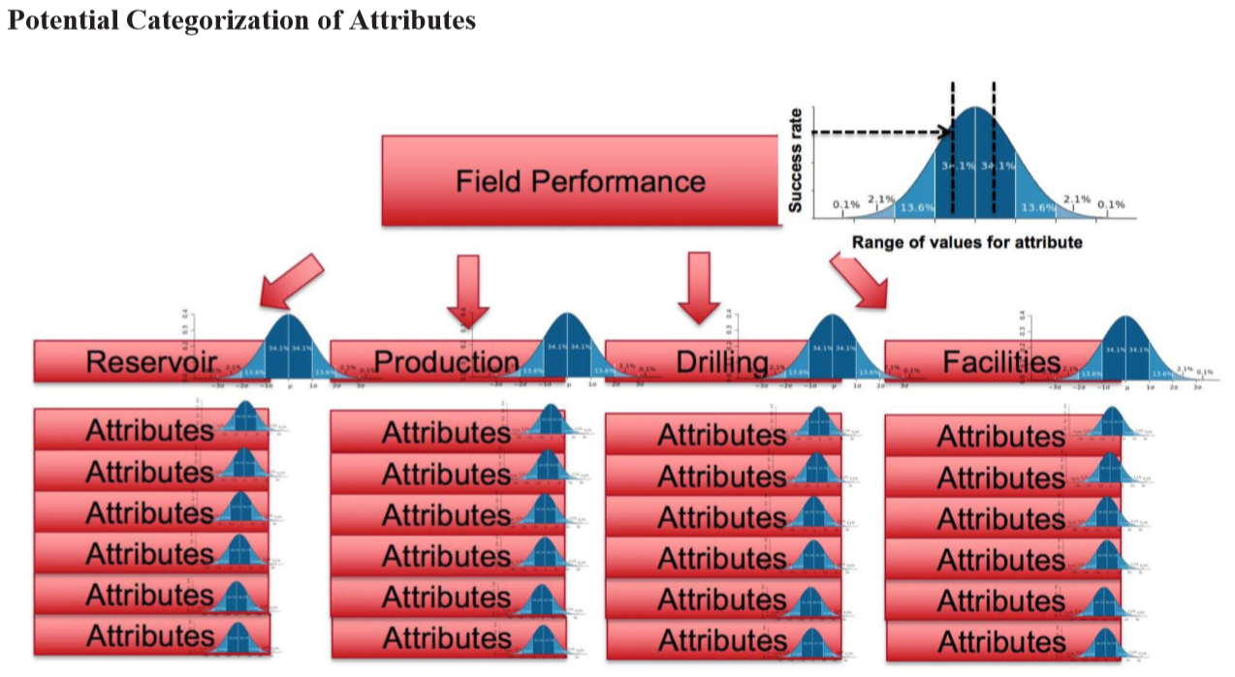

Conclusion

Results and Discussion All field development activities start with high uncertainty and many unknowns. Therefore, data collection campaign starts at the beginning of the exploration phase and it is never finished until the last barrel of oil is produced from the field. Therefore, there is a strong correlation between the available data, gathered from the field throughout its life. When the field matures, available data sizes can reache to terabytes of data from seismic, cores, logs, production reports, PLT, well tests, PVT, etc. However, it is a well-known fact that data collection is expensive and the decision is costly not only for the operation itself but also for production losses due to the data collection campaign. Despite the aforementioned facts, gathering new data from the field is preferred rather than using historical data due to the associated difficulties of handling historical data packages. There is massive data available for the mature fields, and data mining and cleaning up process is painful for modelers. Therefore, requesting new data collection generally easier than struggling with existing data usage, especially if there are no well-organized data storage systems in the company.

Considering the low oil prices that the industry is experiencing nowadays, we are aiming to remind the importance and benefits of building well organized corporate data storage systems and usage of historical data on hand for reservoir management strategies. Importance of turning data into knowledge is illustrated herein this paper and synthetic example for a specific case was given to show how to apply the methodology to obtain the aimed results. Historical data can be utilized rather than synthetic data to find the significance of major parameters in any operation along with optimum values of use for each parameter. This enables the engineer to turn data into knowledge to increase the eifficiency of processes at no significant cost other than time and effort spent for analysis, thereby saving millions of dollars depending on the size of the field and operations. Benefits of using the data are illustrated in this example. The relationship between factors (inputs) and the outcome (outputs) are shown. The ranges where inputs yield lower and higher values of the output are observed. This helps for better designs for future applications, increasing recovery and efficiency in the process through learnings obtained from existing data at no extra significant cost. As far as the relative importance of variables are concerned, fracture half-length is very significant where fracture bottom has more significance than that of fracture top in this specific case. Total proppant used has similar significance as fracture height. Pay zone coverage, slurry volume and average fracture conductivity have similar amounts of significance. The cause-effect (input-output) relationship is shown above for each parameter in the listed figures.

Motores de bases de datos

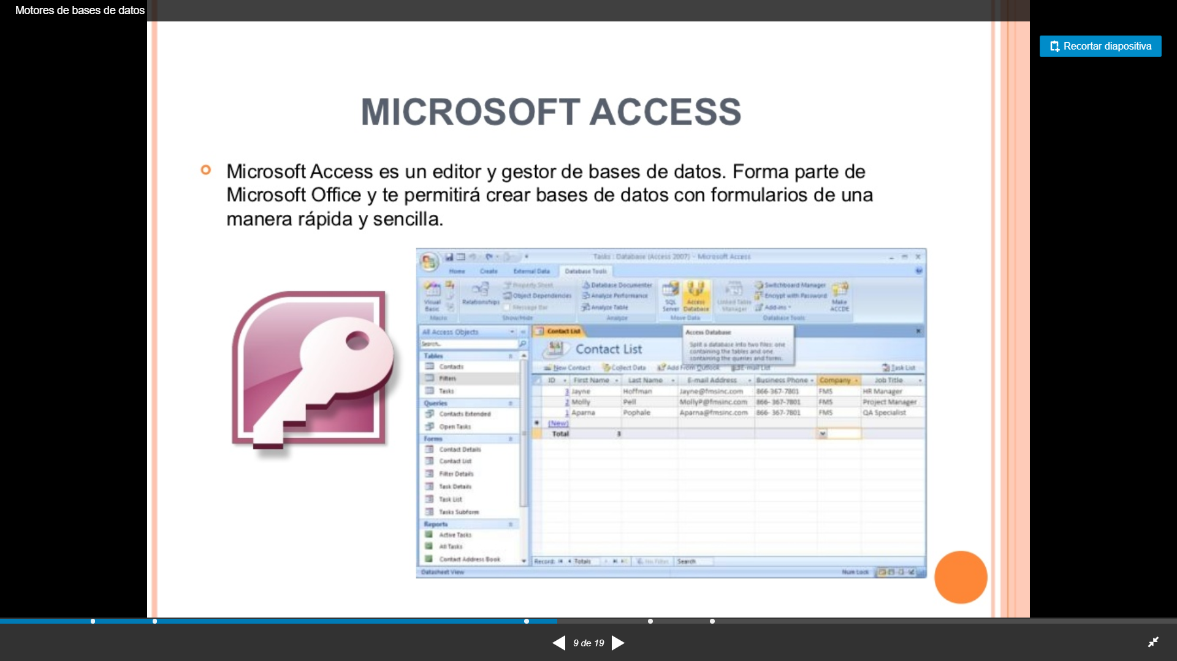

https://yoalme.wordpress.com/2013/03/21/bases-de-datos/

https://es.slideshare.net/still01/motores-de-bases-de-datos

https://blog.pandorafms.org/es/tipos-de-bases-de-datos-y-las-mejores-bases-de-datos-del-2016/

https://www.muylinux.com/2010/03/04/35-motores-de-bases-de-datos-open-source/

